EMPOWHER’25
KNIME INSTALLATION GUIDE
- Team Data Analytics

Download Knime

Step 1.1 : Go to Knime platform - https://www.knime.com/downloads

Step 1.2 : Fill in the details (Not mandatory), Check the highlighted “Terms and conditions” box and click “Download”. Knime is an open source software, so license is not required.
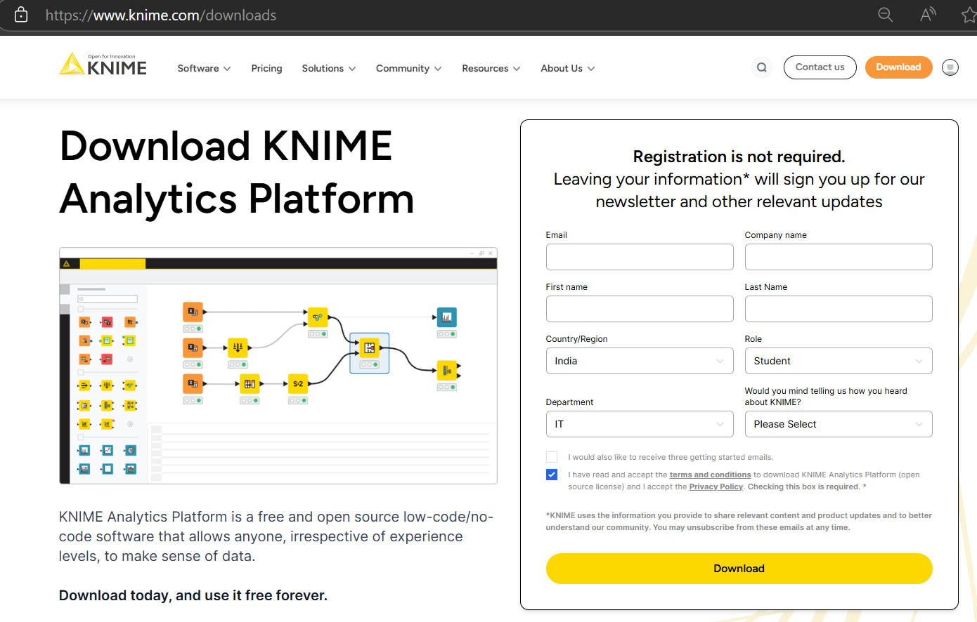

Step 1.3 : Download the latest version – v5.4.3
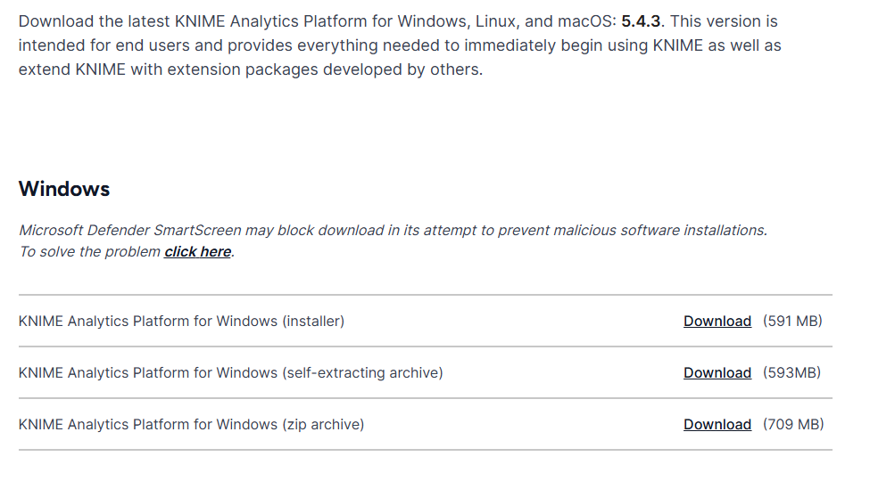

Step 1.4 : Knime file will start downloading automatically.


Install Knime

Step 2.1 : Look for the installer in Download folder of your PC and double click it.

Step 2.2 : Select the below installation mode.
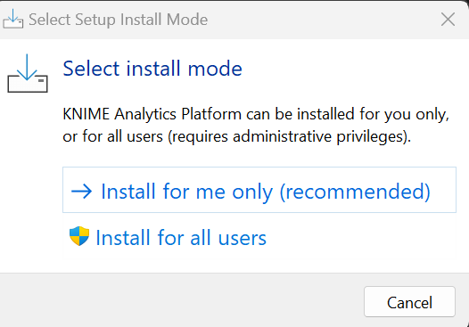

Step 2.3 : Locate the drive where you would like to install and click ‘Next’
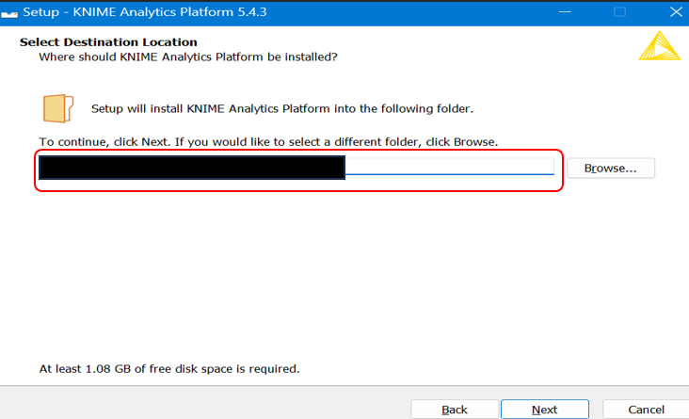

Step 2.4 : Setup folder to be appeared in Start Menu and Click ‘Next’.
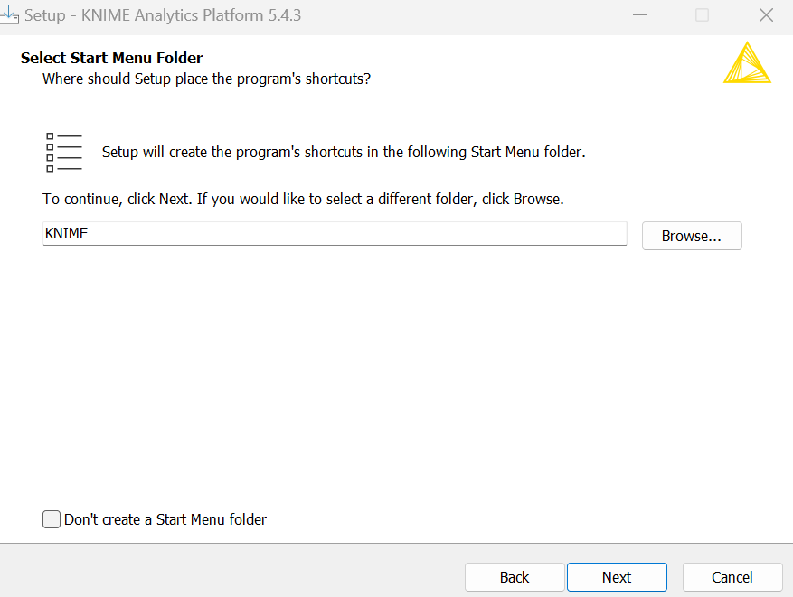

Step 2.5 : Keep the default selection in ‘Additional Tasks’ and ‘Memory Settings’ and Click ‘Next’.
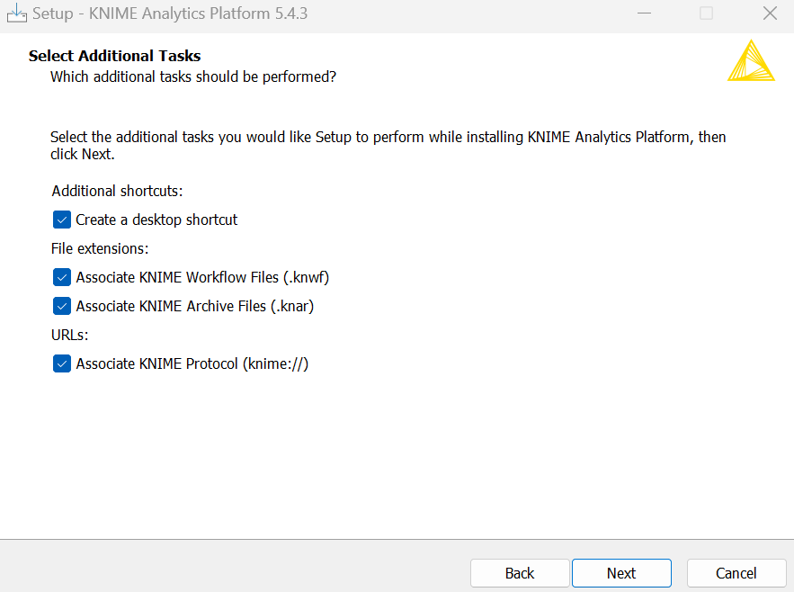
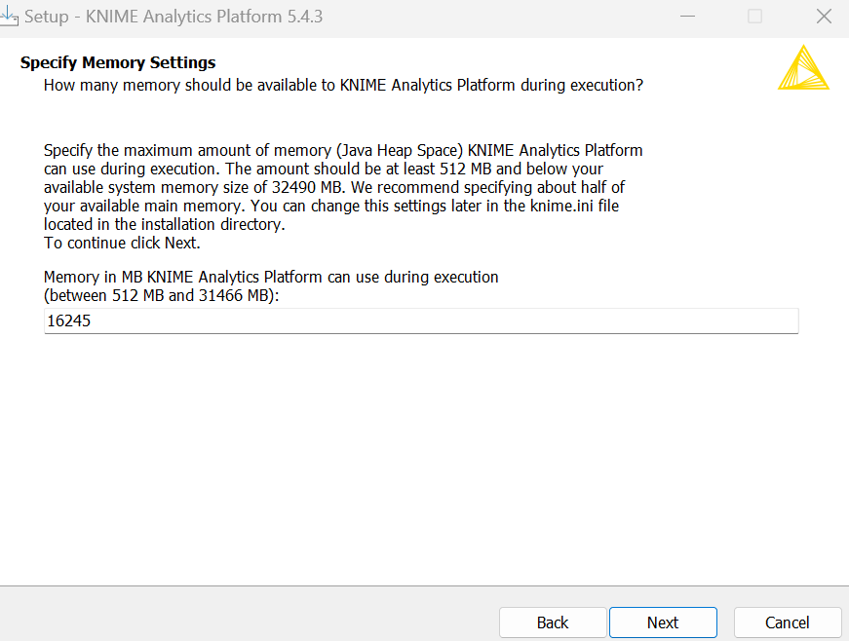

Step 2.6 : Click ‘Install’
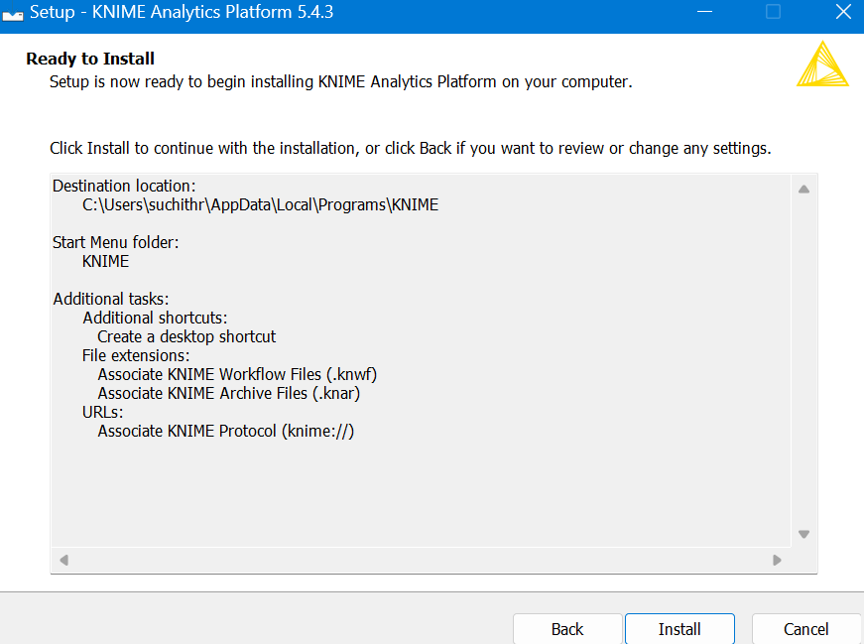

Step 2.7: Once the Installation is complete, Click on ‘Finish’
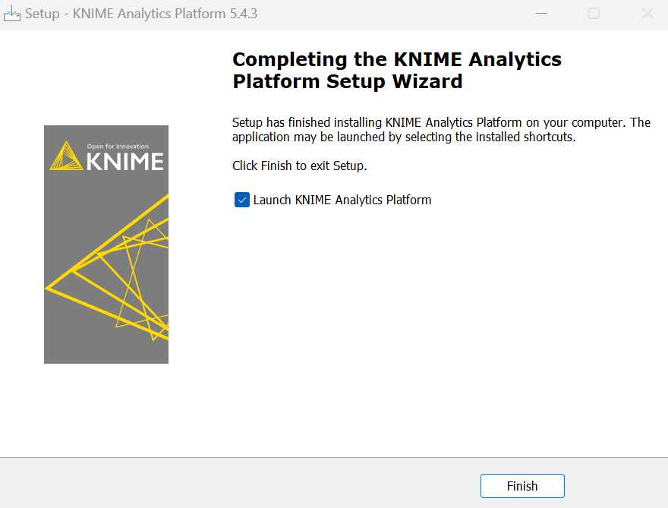

Step 2.8 : Knime App launches automatically, if not look for the App in Start Menu
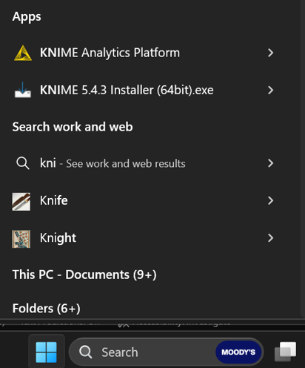

Step 2.9 : Setup workspace location, and click on ‘Launch’.
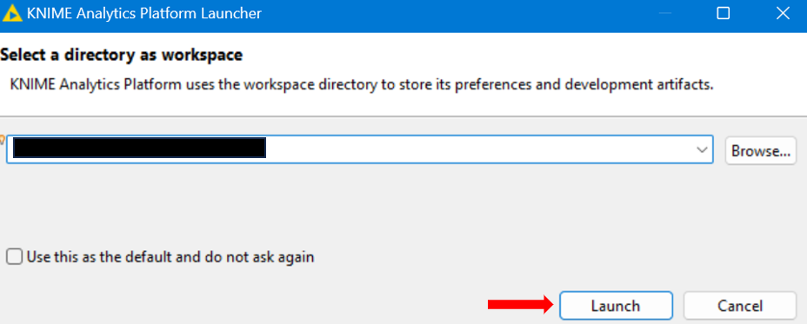

Step 2.10 : Now, The Knime application is ready to use.
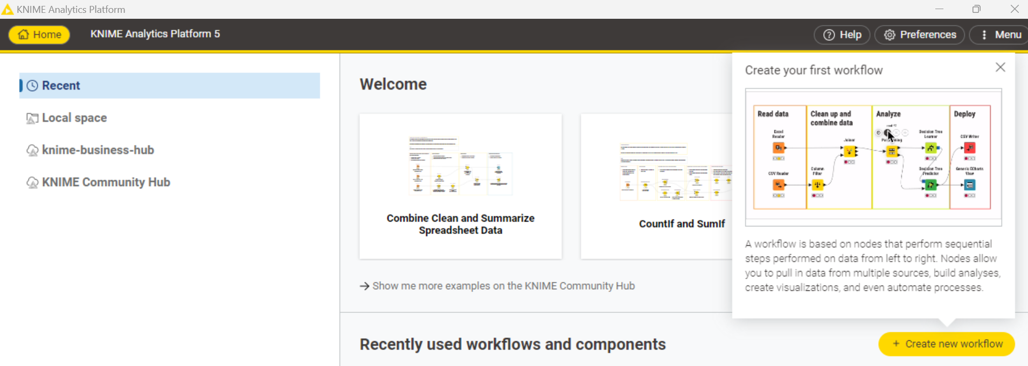

Study Materials
- Quick Start guide
- Knime TV
- Transformation concepts
- Joins

